Puppy Raising Approved Vets List

Region: Sydney/Blue Mountains
After Hours & Critical Care Referral Vets

 | Vet Clinic | Phone | Opening Hours
 | Bass Hill Veterinary Hospital  731 Hume Hwy, Bass Hill | 9724 1927 | 8am-8pm Mon-Fri, 9am-4pm Sat & Sun
 | Animal Referral Hospital  19 Old Northern Rd, Baulkham Hills | 9639 7744 | 6pm-8am, Tue-Thu 6pm-12am, Fri  Open 24hrs, Sat-Mon
Veterinary Emergency Care Australia (VECA)  5/10 Blaxland Rd, Campbelltown NSW 2560 |  | - 5888 | 24 hours / 7 days a week reception@veca.com.au
 | Animal Referral Hospital  250 Parramatta Road, Homebush | 9758 8666 | 24/7
 | Ingleburn Veterinary Hospital  4/2 Noonan Road, Ingleburn | 9546 5600 | 8am-7pm Mon-Fri 8am-3pm Sat
 | Animal Referral Hospital  5/1 John Hines Ave, Minchinbury | 8610 3400 | 8am -12am Mon/Tues/Thur/Fri4pm-12am Wed  2pm 12am Sat (as of 1/3/25) and Sunday
 | Veterinary Specialists of Sydney  106 Parraweena Rd, Miranda | 8376 8767 | 24/7 for Emergencies
 | Small Animal Specialist Hospital  Level 1, 1 Richardson Place, North Ryde | 9199 8935 | 24/7 for Emergencies
 | Colyton Veterinary Hospital  81 Great Western Highway, Oxley Park | 9673 1106 | 8am-7pm Mon-Fri  9am-2pm Sat and Sun
 | Nepean Animal Hospital  50 Mulgoa Road, Regentville | 4733 3456 | 9am-7pm Mon-Fri  9am-6pm Sat & Sun 24/7 for Emergencies
 | Northside Emergency Veterinary Service  335 Mona Vale Road, Terry Hills | 9452 2933 | 7pm-8am, Mon-Fri Sat 12noon-Mon 8am  All day, Public Holidays
 | Vineyard Veterinary Hospital  703 Windsor Road, Vineyard | 9627 1257 | 8.30am-6pm Mon-Fri 9am-1.30pm Sat  9am-12pm Sun

Routine Vet Care & In Hours Emergency Clinics

Vet Clinic | Phone | Opening Hours
Allison Crescent Veterinary Hospital  Shop 13, Menai Metro, 72-80 Allison Crescent, Menai | 9543 5843 | 8:30am-5:00pm Mon-Fri
Bass Hill Veterinary Hospital  731 Hume Hwy, Bass Hill | 9724 1927 | 8am-8pm Mon-Fri, 9am-4pm Sat & Sun
Beecroft Vet  Shop 2, 3-5 Wongala Cres, Beecroft | 8914 0828 | 7:30am-8pm Mon-Fri, 9am-6pm Sat & Sun
Bondi Junction Veterinary Hospital  12 Elby Street, Bondi Junction | 9389 8411 | 8am-7pm Mon-Fri  9am-7pm Sat & Sun
Uni Vets Camden  410 Werombi Road, Brownlow Hill | 4655 0777 | 8am-5pm Mon-Fri, 8am-3.30pm Sat
Camden Valley Way Vet Hospital  2 Exchange Pde, Smeaton Grange | 4647 6199 | Mon-Fri 8am-7pm; Sat 9am-1pm
Como Veterinary Clinic  62 Wolger Street, Como | 9589 0022 | 9-11.30am & 3-7pm Mon-Fri, 2-3pm Sat
Dural Veterinary Clinic  687 Old Northern Road, Dural | 9651 1100 | 8.30am-7pm Mon-Fri, 8.30am-4pm Sat
Elanora Veterinary Clinic  2/53 Kalang Rd, Elanora Heights | 9970 6647 | 8:30am-6:30pm Mon-Fri, 9am-12pm Sat
Enfield Veterinary Hospital  94 Coronation Pde, Enfield | 9747 3999 | 8am-7:30pm Mon-Fri, 8am-4pm Sat, 8:30am-2pm Sun  9am-12pm Public Hols
Epping Veterinary Clinic  76 Carlingford Road, Epping | 9869 2771 | 8am-7pm Mon-Fri, 9am-4pm Sat,  10am-4pm Sun
Frenchs Forest Veterinary Hospital  24 Forest Way, Frenchs Forest | 9452 1066 | 8am-7pm Mon-Fri, 8am-3pm Sat
Selwood House Vet Hospital  41 Railway Parade, Hazelbrook | 4758 8990 | 8.30am-6.30pm Mon-Fri, 8.30am-12.30pm Sat
Hornsby Veterinary Hospital  6 Leonard Street, Hornsby | 9477 1233 | 8am-7pm Mon-Fri, 8am-5pm Sat, 10am-1pm Sun
Connells Point Veterinary Surgery  1/65 Connells Point Rd, Hurstville South | 9546 5600 | 9am-12pm & 3:30-6pm Mon-Fri 9am-12pm Sat (Closed Sun)
Ingleburn Veterinary Hospital  4/2 Noonan Road, Ingleburn | 9546 5600 | 8am-7pm Mon-Fri 8am-3pm Sat
Kogarah Veterinary Hospital  (Benny & the Pets)  39 President Ave, Kogarah | 9588 4588 | 8am-1pm & 3pm-7pm Mon-Fri  9am-5pm Sat  10am-4pm Sun
Kurrajong Veterinary Clinic  16 Old Bells Line of Road, Kurrajong | 4573 1216 | 8am-6.30pm Mon-Fri 9am-12pm Sat
Annandale Animal Hospital  62 Moore St, Leichhardt | 9550 9600 | 8am-8pm Mon-Fri 9am-5pm Sat  9am-1pm & 2-5pm Sun
Ark Veterinary Hospital  352 Pacific Hwy, Lindfield | 9416 1300 | 8am-7pm Mon-Fri 9am-4pm Sat  10am-1pm Sun
The Beaches Vet  Shop 1, 285 Condamine St, Manly Vale | 9170 2845 | 7:30am-7:30pm Mon-Fri 9am-2pm Sat
Matraville Veterinary Practice | 9189 4488 | 7.30am-8pm Mon-Fri
525 Bunnerong Road, Matraville |  | 9am – 6pm Sat & Sun
Merrylands Vet  122 Merrylands Rd, Merrylands | 9682 1547 | 8am-7pm Mon & Fri 9am-7pm Tue-Thu 9am-12pm Sat
Mona Vale Veterinary Hospital  22 Park Street, Mona Vale | 9999 2269 | 8am-6pm Mon-Fri 8am-2pm Sat  8am-10am Sun
Normanhurst Vet Practice  31 Normanhurst Road, Normanhurst | 9489 6000 | 8am-7pm Mon-Fri 8am-4pm Sat  10am-12pm Sun
North Richmond Vet Hospital  61 Yobarnie Ave, North Richmond | 4571 2042 | 8am-12pm & 4pm-7pm Mon-Fri 9am-12pm Sat
Colyton Veterinary Hospital  81 Great Western Highway, Oxley Park | 9673 1106 | 8am-7pm Mon-Fri  9am-2pm Sat and Sun
Parramatta Vet Hospital  100 Grose Street, Parramatta | 9630 5520 | 8.30am – 6pm Mon-Fri  Closed Weekends and Public Holidays
Pet Medical Milsons Point  28 Alfred St South, Milsons Point | 8203 4390 | 8am-6pm Mon-Fri; 9am-2pm Sat
Pendle Hill Veterinary Clinic  215 Wentworth Avenue, Pendle Hill | 9636 5641 | 8am-7pm Mon-Fri 9am-12pm Sat  9-11am Sun.
Gordon Vet Hospital  19 Ryde Road, Pymble | 9498 3000 | 7am-7pm Mon-Fri  7.30am-5pm Sat, 9-11am Sun
Quakers Hill Veterinary Hospital  138 Burdekin Road, Quakers Hill | 9626 9561 | 9am-6pm Mon-Fri 8.30am-2.30pm Sat  8.30am-2pm Sun
Ramsgate Vet  231 Rocky Point Road, Ramsgate | 9133 1303 | 8am-7pm Mon-Fri  10am-4pm Sat & Sun
Bayside Animal Hospital  Shop G34, 11-21 Marquet St, Rhodes | 7204 8119 | 8:30am-7pm Mon-Fri 10am-5pm Sat-Sun
Vets on Crown  537 Crown St, Surry Hills | 9133 1300 | 7:30am-8pm Mon-Fri 10am-4pm Sat & Sun
Sutherland Veterinary Clinic  37 East Parade, Sutherland | 9545 2100 | 9am-7pm Mon-Fri 9am-12pm Sat  10.30am-2.30pm Sun
Vineyard Veterinary Hospital  703 Windsor Road, Vineyard | 9627 1257 | 8.30am-6pm Mon-Fri 9am-1.30pm Sat  9am-12pm Sun
Willoughby Veterinary Hospital  193 High St, Willoughby | 9958 8775 | 8am-8pm Mon-Fri  9am-4pm Sat, 10am-12pm Sun
Bayside Animal Hospital  Shop 1, 1 Guess Ave, Wolli Creek | 7901 0837 | 8am-8pm Mon-Fri 10am-5pm Sat-Sun

Sydney/Blue Mountains Map

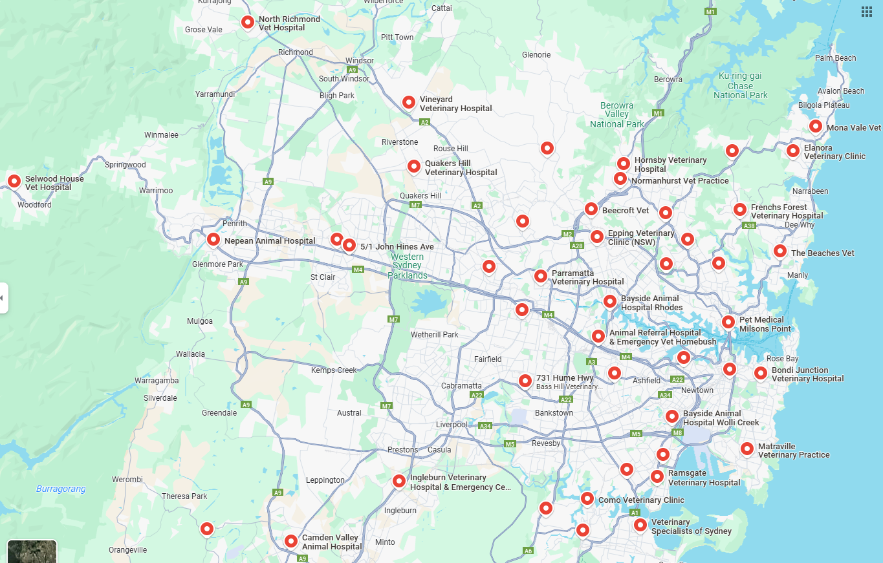

Region: South Coast
After Hours & Critical Care Referral Vets

Vet Clinic | Phone | Opening Hours
Bomaderry Veterinary Hospital  335 Princes Highway, Bomaderry | 4421 3133 | 24/7 for Emergencies
Animal Referral Hospital Wollongong  1/3 Princes Highway, Fairy Meadow, NSW 2519 | 4283 8432 | Mon-Fri 6pm – 7am  Saturday & Sunday: Open 24 hours

Routine Vet Care & In Hours Emergency Clinics

Vet Clinic | Phone | Opening Hours
Austinmer Veterinary Hospital  2/67 Moore St, Austinmer | 4268 3353 | 8am-7pm Mon-Fri; 8am-2pm Sat; 9am-12pm Sun
Bomaderry Veterinary Hospital  335 Princes Highway, Bomaderry | 4421 3133 | 8:30am-2pm & 3-6pm Mon-Fri 9am-1pm Sat & Sun  24/7 for emergencies
Curley’s Bay Veterinary Hospital  19 Weston Street, Culburra Beach | 44213528 | 9am-5pm Mon-Fri
Illawarra Animal Hospital  43 Princes Hwy, Figtree | 4213 9333 | 8am-8pm Mon-Thu 8am-6pm Fri-Sun
Southern Highlands Veterinary Centre  48 Berrima Road, Moss Vale | 4868 1310 | 8:30am-6pm Mon-Fri 8:30am-12pm Sat
Shoalhaven Heads Veterinary Clinic  2/133 Shoalhaven Heads Road, Shoalhaven Heads | 4448 5621 | 9am-5:30om Mon-Fri
Illawarra Animal Hospital  24 Princes Highway, Yallah | 4257 3322 | 8am-6pm Mon-Fri

South Coast Map

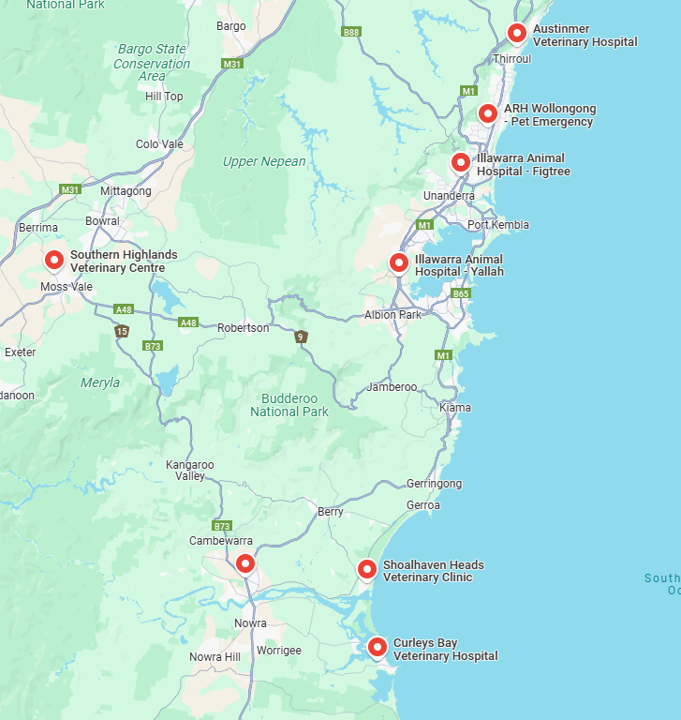

Region: Newcastle
After Hours & Critical Care Referral Vets

Vet Clinic | Phone | Opening Hours
Animal Referral and Emergency Centre  4 Lang Road Broadmeadow | 1300 838 669 | 24/7 for Emergencies

Routine Vet Care & In Hours Emergency Clinics

Vet Clinic | Phone | Opening Hours
Bonnells Bay Animal Hospital  25 Station Street, Bonnells Bay | 4973 1411 | 9am-4:30pm Mon-Thu 9am-12pm Fri
Cooranbong Animal Hospital  673 Freemans Drive, Cooranbong | 4977 3177 | 8:30am-6pm Mon-Fri  9am-12pm Sat, 9-11am Sun
Greenhills Veterinary Hospital  19 Mitchell Drive, Greenhills | 4934 1900 | 8:30am-6pm Mon-Fri  ONLY TO BE USED ON WEEKDAYS
Merewether Veterinary Hospital  2/25 Llewellyn Street, Merewether | 4969 2694 | 8am-7pm Mon-Fri  9am-12pm & 6-7pm Sat 10-11am & 6-7pm Sun
Nelson Bay Vet  13 Yacaaba St, Nelson Bay | 4981 1033 | 9am-5pm Mon-Fri
Rathmines Vet Hospital  5 Immarna Rd, Rathmines NSW 2283 | 4975 3366 |  | Opening Hours: Mon-Fri 8am – 6:30pm
Tea Gardens Vet Hospital  2/197 Myall St, Tea Gardens | 4997 1877 | 9am-5pm Mon-Fri

Newcastle Map

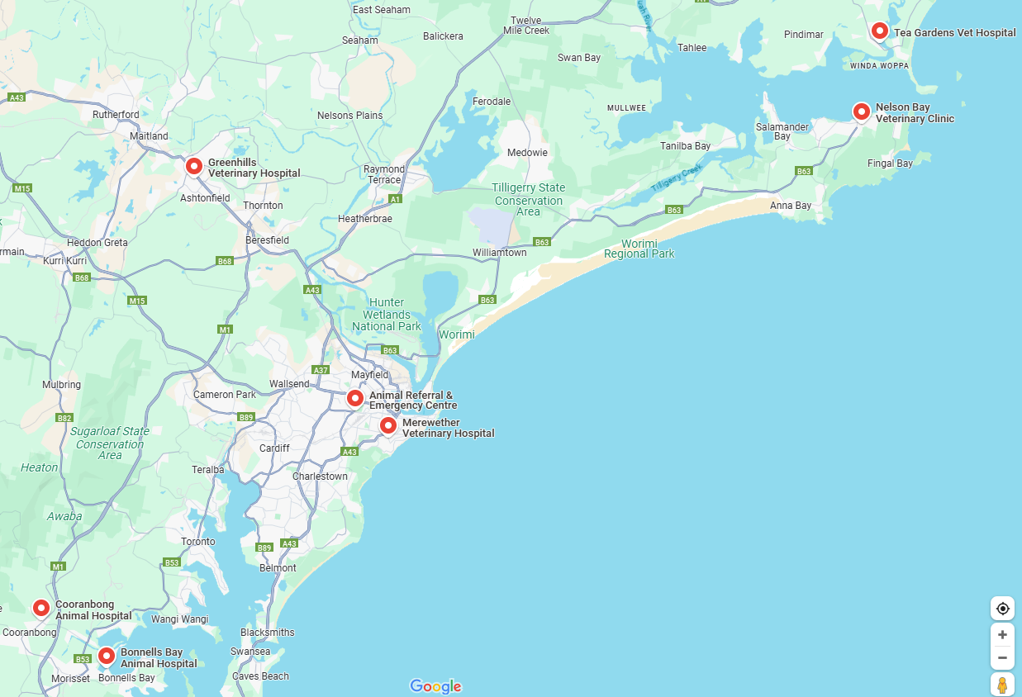

Region: ACT
After Hours & Critical Care Referral Vets

Vet Clinic | Phone | Opening Hours
Bungendore Veterinary Surgery  112B Molongolo Street, Bungendore | 6238 1133 | 24/7 for Emergencies
Canberra Veterinary Emergency Service  21 Crinigan Circuit, Gungahlin | 6225 7257 | 24/7 for Emergencies

Routine Vet Care & In Hours Emergency Clinics

Vet Clinic | Phone | Opening Hours
Belconnen Veterinary Centre  30 Totterdell St, Belconnen, ACT, 2617  - info@belconnenvets.com.au | 5134 6999 | Mon-Fri 8am-6pm; Sat 10am-4pm
Bungendore Veterinary Surgery  112B Molongolo Street, Bungendore | 6238 1133 | 8am-7pm Mon & Wed  8am-5:30pm Tue, Thu, Fri 9am-1pm Sat  24/7 for Emergencies
Gundaroo Veterinary Centre  15 Faithfull St, Gundaroo, NSW, 2620  - info@gundaroovets.com.au | 6236 8222 | Mon-Fri 8am-6pm
Manuka Veterinary Hospital  85 Flinders Way, Griffith | 6295 6089 | 8am-7pm Mon-Fri 8:30am-2pm Sat
The Foreshore Vet  12/1 The Causeway, Kingston | 6188 4255 | 8:30am-5:30pm Mon-Fri 9am-12pm Sat

ACT Map

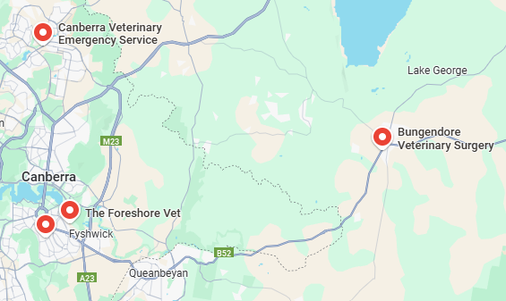
After Hours & Critical Care Referral Vets

Vet Clinic | Phone | Opening Hours
Animal Referral Hospital and Emergency Centre  3/401 Manns Road, Gosford | 4323 3886 | 24/7 for Emergencies
SASH Central Coast  2 Bounty Close Tuggerah | 4311 1311 | 24/7 for Emergencies
Routine Vet Care & In Hours Emergency Clinics

Vet Clinic | Phone | Opening Hours
Brisbane Water Veterinary Hospital  52 Memorial Ave, Blackwall | 4342 0200 | 8am-7pm Mon-Fri; 9am-2pm Sat
Green Point Veterinary Hospital  321 Davistown Road, Green Point | 4369 3943 | 8:30am-6:30pm Mon-Fri 8:30am-12:30pm Sat  10am-2pm Sun
Coastal Animal Health  231 Wallarah Road, Kanwal | 4392 8822 | 8am-6pm Mon-Fri 9am-5pm Sat
Central Coast Map

