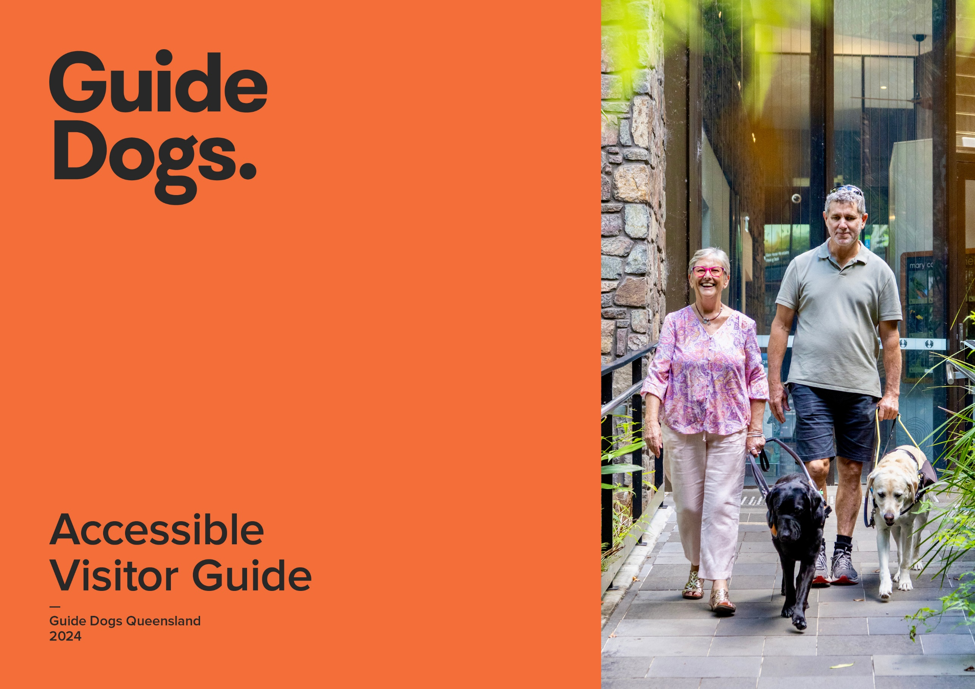

**Accessible guide – [insert your location/experience name]**

|  |  |  |
| --- | --- | --- |
| **Accessible rooms** | **Availability** | **Details** |
| Is there accessible accommodation?  Is the entry door a good width?  Are door handles easy to use?  Is there movement space at the door?  Are there visual alarm devices (VAD)? | **Yes** | **Example: 2 rooms** |
| **Accessible bathroom** |  |  |
| Does the bathroom have good door width?  Is there an accessible toilet?  Are there grab rails?  Is there clearance under the basin?  Is there a roll-in shower?  Is there a shower chair? | **Yes** | **Example: Door width 867mm** |
| **Bedding** |  |  |
| Is the bed at a good height for transferring?  Is there clearance around the bed?  Is there clearance under the bed? | Yes/No/Partial/ NA  **Yes** | **Example: 65mm H** |
| **Furniture and fittings** |  |  |
| Are switches/controls reachable seated?  Is the furniture easy to move?  Is clothes storage at a good height? | Yes/No/Partial/ NA | **Example: Heavy chairs, staff happy to help** |

|  |  |  |
| --- | --- | --- |
| **Kitchen** |  |  |
| Are there cooking facilities?  Are appliances reachable while seated?  Are utensils reachable while seated? | Yes/No/Partial/ NA  **Yes** | **Example: Located in second drawer** |
| **Balcony/courtyard** |  |  |
| Is there level access to balcony/courtyard?  Is the doorway a good width? | Yes/No/Partial/ NA | **Example:** |
| **Arrival, entry and facilities** |  |  |
| Are there designated car parks?  Are they undercover with good clearance?  Is there a drop-off point?  Is the main entry path level and barrier-free? | Yes/No/Partial/ NA  **No** | **Example:** |
| **Reception and entry** |  |  |
| Is there a reception?  Is the entry door a good width?  Is there a Hearing Loop?  Is there a low-height counter?  Are there good seating options? | Yes/No/Partial/ NA  **No** | **Example:** |
| **Common areas** |  |  |
| Are walkways wide and level?  Is there clear signage?  Is the signage Braille/tactile?  Is there free Wi-Fi?  Is there a sensory or quiet space?  Is there a café or restaurant? | Yes/No/Partial/ NA  **Yes** | **Example: Available in rooms and some common areas** |

|  |  |  |
| --- | --- | --- |
| **Common areas (continued)** |  |  |
| Are there good seating options?  Are there conference rooms?  Are there accessible toilets? |  |  |
| **Lifts** |  |  |
| Do the lifts cater for visitors with low vision or blindness?  Does the lift have good circulation space? | Yes/No/Partial/ NA  **Yes** | **Example: 1094mm W x 2000mm D** |
| **Swimming pool** |  |  |
| Is there a swimming pool?  Is the pool wheelchair accessible?  Are there steps and handrails? | Yes/No/Partial/ NA |  |

